**EXP 7 Store user preference using cookies**

**AIM:**

To create web page to store and retrieve user preferences using cookies.

**ALGORITHM:**

• **Display form** with theme and language options in HTML.

• On **page load**, JavaScript reads cookies for saved preferences.

• **Pre-fill form** and apply theme (e.g., dark mode) using cookie values.

• On **form submit**, send data to the servlet via POST.

• **Servlet receives** theme and language, creates cookies, and sets expiry.

• Servlet **adds cookies to response** and redirects to the form page.

• On next visit, preferences are **loaded from cookies and displayed**.

**PROGRAM:**

**UserPreferencesServlet.java (Servlet code)**

import java.io.IOException;

import javax.servlet.*;

import javax.servlet.http.*;

public class UserPreferencesServlet extends HttpServlet {

protected void doPost(HttpServletRequest request, HttpServletResponse response) throws IOException {

String theme = request.getParameter("theme");

String language = request.getParameter("language");

Cookie themeCookie = new Cookie("theme", theme);

Cookie langCookie = new Cookie("language", language);

themeCookie.setMaxAge(60 * 60 * 24 * 7); // 7 days

langCookie.setMaxAge(60 * 60 * 24 * 7);

response.addCookie(themeCookie);

response.addCookie(langCookie);

response.sendRedirect("index.html"); // Reload page

}

}

**web.xml (Servlet Mapping)**

<web-app>

<servlet>

<servlet-name>UserPreferencesServlet</servlet-name>

<servlet-class>UserPreferencesServlet</servlet-class>

</servlet>

<servlet-mapping>

<servlet-name>UserPreferencesServlet</servlet-name>

<url-pattern>/savePreferences</url-pattern>

</servlet-mapping>

</web-app>

**index.html (Stylish UI with HTML/CSS/JS + cookie reading)**

<!DOCTYPE html>

<html lang="en">

<head>

<meta charset="UTF-8" />

<title>User Preferences</title>

<style>

body {

font-family: 'Segoe UI', sans-serif;

margin: 0;

padding: 50px;

background: linear-gradient(to right, #f9f9f9, #dfe9f3);

transition: background-color 0.3s, color 0.3s;

}

.container {

max-width: 500px;

margin: auto;

padding: 30px;

background: #fff;

box-shadow: 0 0 20px rgba(0,0,0,0.1);

border-radius: 12px;

**}**

h2 {

text-align: center;

color: #5c67f2;

}

form {

display: flex;

flex-direction: column;

}

label {

margin: 10px 0 5px;

}

select, button {

padding: 10px;

border-radius: 8px;

border: 1px solid #ccc;

}

button {

background: #5c67f2;

color: white;

margin-top: 20px;

border: none;

cursor: pointer;

transition: background 0.3s;

}

button:hover {

background: #4a54e1;

}

#prefs {

margin-top: 20px;

background: #eef1ff;

padding: 15px;

border-radius: 10px;

}

</style>

</head>

<body>

<div class="container">

<h2>Set Your Preferences</h2>

<form method="POST" action="savePreferences">

<label for="theme">Theme:</label>

<select name="theme" id="theme">

<option value="light">Light</option>

<option value="dark">Dark</option>

</select>

<label for="language">Language:</label>

<select name="language" id="language">

<option value="English">English</option>

<option value="Spanish">Spanish</option>

<option value="French">French</option>

</select>

<button type="submit">Save Preferences</button>

</form>

<div id="prefs">

<h3>Saved Preferences</h3>

<p><strong>Theme:</strong> <span id="savedTheme">N/A</span></p>

<p><strong>Language:</strong> <span id="savedLanguage">N/A</span></p>

</div>

</div>

<script>

function getCookie(name) {

let decoded = decodeURIComponent(document.cookie);

let cookies = decoded.split(';');

for (let cookie of cookies) {

let c = cookie.trim();

if (c.startsWith(name + '=')) {

return c.substring(name.length + 1);

}

}

return null;

}

window.onload = () => {

const theme = getCookie('theme') || 'light';

const language = getCookie('language') || 'English';

document.getElementById('theme').value = theme;

document.getElementById('language').value = language;

document.getElementById('savedTheme').textContent = theme;

document.getElementById('savedLanguage').textContent = language;

// Optional: Apply dark mode

if (theme === 'dark') {

document.body.style.background = '#1f1f1f';

document.body.style.color = '#fff';

}

};

</script>

</body>

</html>

**OUTPUT:**

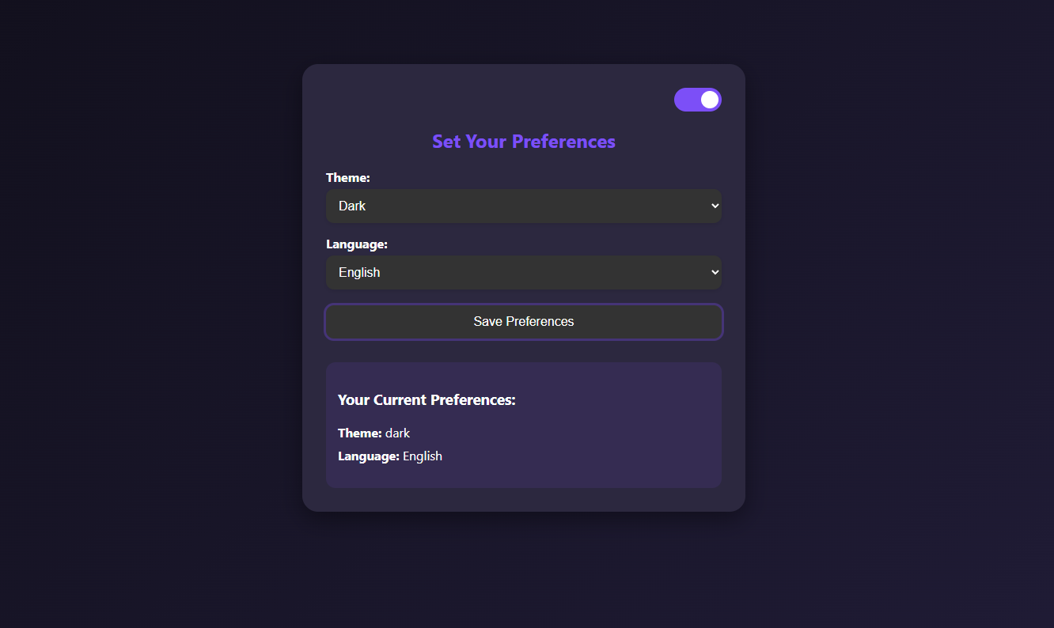

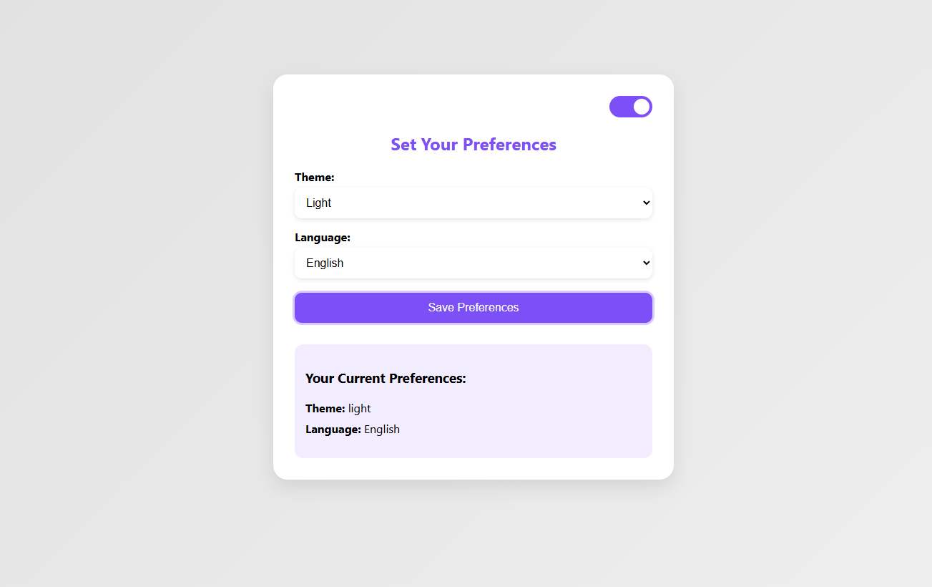

**RESULT:** The Session Tracking using HttpSession were executed successfully.